PCAWG results
TMB and FGA correlation with the number of clusters

Positive correlation between TMB and number of clusters. This can be genuine, mutagens can also induce CNAs, but can also be due to the fact that higher TMB facilitate the distinction of clusters. Checking the correlation between TMB and FGA we could only see weak correlations in some cancer types. Unfortunately, we see that the model successfully manages to call more than one cluster only when TMB is higher than certain threshold

As expected, the WGD tend to cluster at high FGA, HM are in the middle.

Cancer types ordered by TMB
Abbreviation | Cancer type
DLBCLNOS | Diffuse Large B-Cell Lymphoma (hematological, Blood cancers typically have lower TMB because they arise from cells with lower replication rates and less exposure to exogenous mutagens.)
LUSC | Lung Squamous Cell Carcinoma (Carcinogen-exposed epithelial tumors) weird that those are here, possibly because of low number of samples and the fact the we excluded complex CNA, so maybe we miss samples with higher TMB -> NEED TO CHECK
BLCA | Bladder Carcinoma (Carcinogen-exposed epithelial tumors)
LUAD | Lung Adenocarcinoma (Carcinogen-exposed epithelial tumors)
HNSC | Head & Neck Squamous Cell Carcinoma
CHRCC | Chromophobe Renal Cell Carcinoma
PAST | Pilocytic Astrocytoma (Pediatric cancers, expected low TMB)
UCEC | Uterine Corpus Endometrial Carcinoma
AML | Acute Myeloid Leukemia
COADREAD | Colorectal Adenocarcinoma (It’s surprising that’s not at the top, might be enriched for MSS, we excluded the MSI because of complex CAN, we could asses this by checking the mutational signatures analysis)
PANET | Pancreatic Neuroendocrine Tumour
MBL | Medulloblastoma
CLLSLL | Chronic Lymphocytic Leukemia / Small Lymphocytic Lymphoma
OS | Osteosarcoma
BRCA | Breast Carcinoma
PRAD | Prostate Adenocarcinoma
PAAD | Pancreatic Ductal Adenocarcinoma
MLYM | Mature B-cell lymphoma / Myeloma
OVT | Ovarian Tumour
CHOL | Cholangiocarcinoma
STAD | Stomach Adenocarcinoma
CCRCC | Clear Cell Renal Cell Carcinoma
NHL | Non-Hodgkin Lymphoma
HCC | Hepatocellular Carcinoma: aflatoxin/HBV mutagenesis (typically high TMB)
ESCA | Esophageal Carcinoma: alcohol/tabacco mutagenesis (Carcinogen-exposed epithelial tumors, typically high TMB)
MEL | Melanoma: UV induced C>T mutations (typically high TMB)

When ordered by FGA some ttypes flip their order (DLBCLNOS, LUSC, BLCA, LUAD)

Some of the results look genuine, other though are odd. I’d check:
- The characteristics of the samples we excluded for LUSC, BLCA, LUAD, COADREAD, to verify what kind of samples we excluded and why since we seem to have a bias for low TMB samples
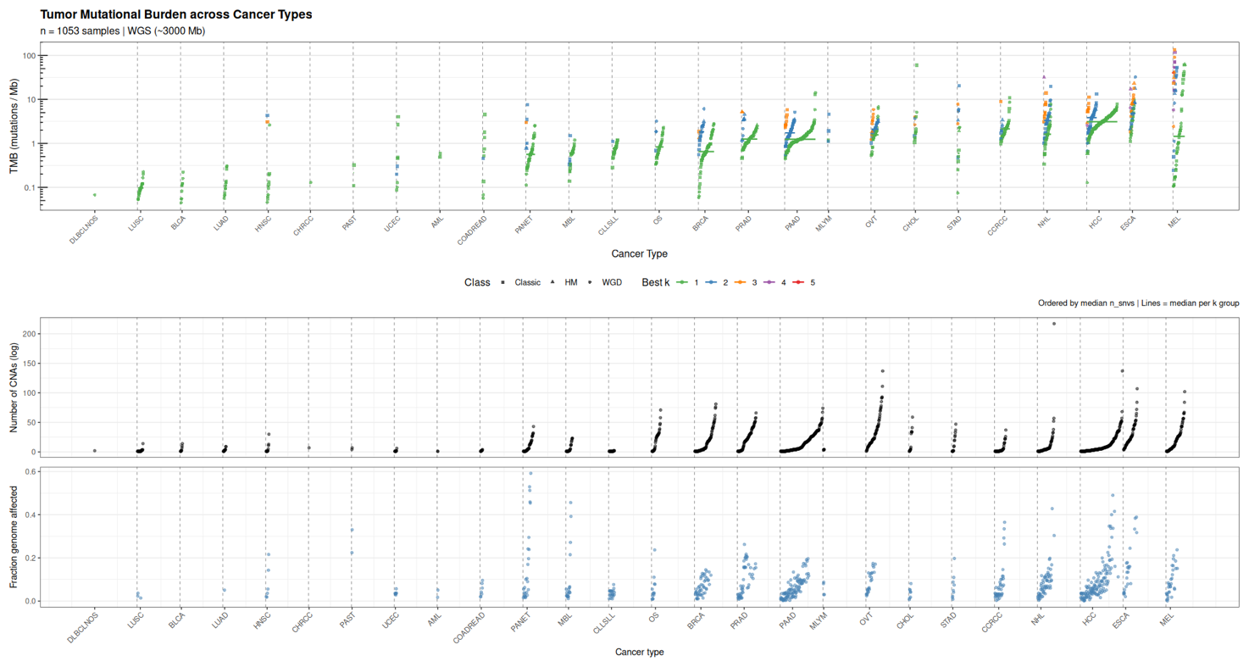
We might check whether there are some specific drivers associated to longer CNA evolution (higher number of clusters). This could strengthen our claim that the signal we see is genuine and not just due to the fact that having more mutations grants us more resolution. I would also be interesting to see if we can pick up differences in the CNA signature contents of the different clusters, see if there are different mechanisms at play forming each “burst”. This again would strengthen our claim over the presence of the clusters.
During the signature deconvolution I’d check:
- That we find mutagens-associated signatures (UV, tabacco…) more often in early evlution (alpha mutations). This is just a confirmation of what’s expected (in the alpha – beta analysis)

Analysis
Check the distribution of time per class of samples: in each tumor type, when do WGD happen most frequently?

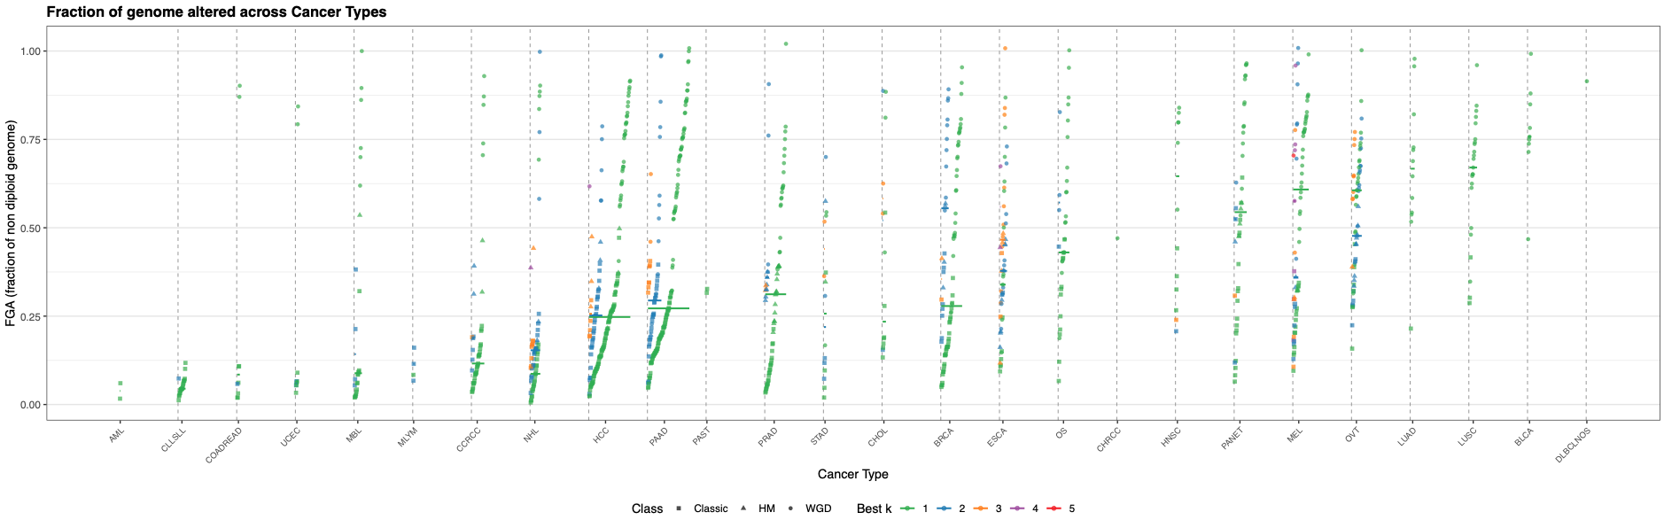

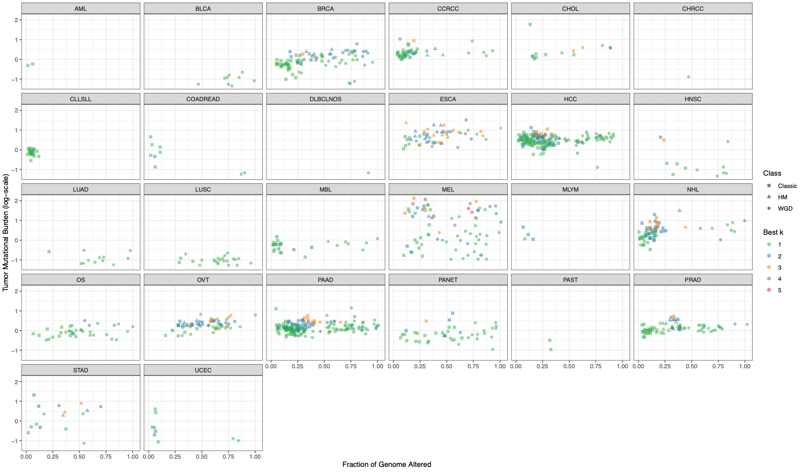

Arm-level events patters
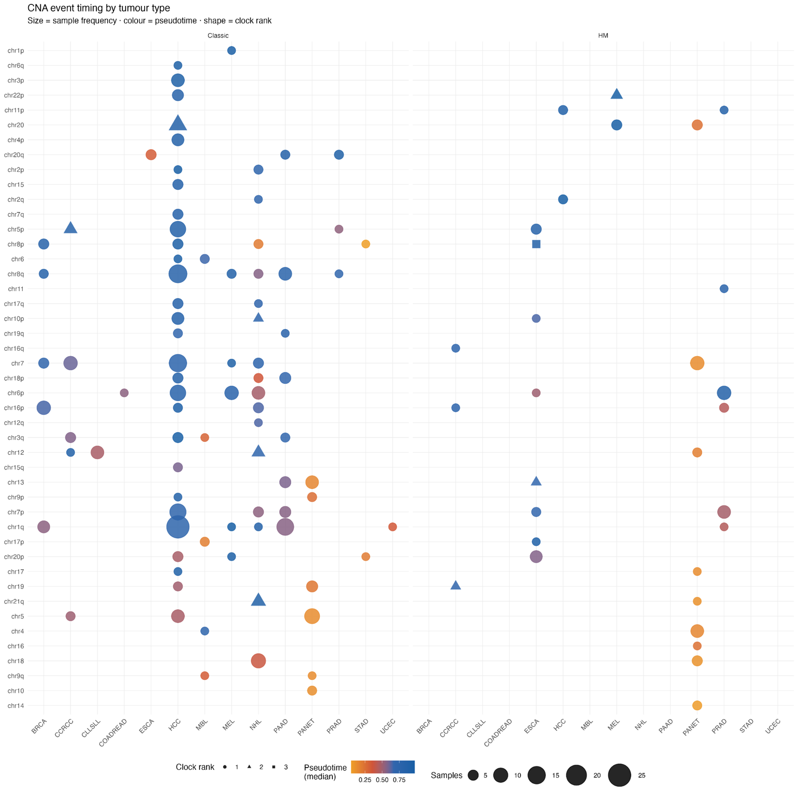
Events that recur across cancers (“gravity wells of evolution”):
- 8q gain (MYC),
- 17p loss (TP53),
- 9p loss (CDKN2A),
- 8p loss (NKX3.1, PRLTS, and other TSGs)
CCRCC: simultaneous loss of 3p and gain of 5q typically occurs through chromothripsis in childhood or adolescence, generally as the initiating event that precedes emergence of the tumor's most recent common ancestor by years to decades. This is extraordinary — the founding genomic event happens before puberty. (https://pmc.ncbi.nlm.nih.gov/articles/PMC5927631/)
BRCA: gain of 1q and losses on 16q, 10q, 22q and 7q were recurrent across donors and present in a rare population of cells across almost all samples examined, even before loss of heterozygosity of wild-type BRCA1/BRCA2 alleles. So 1q gain is pre-malignant. (https://pubmed.ncbi.nlm.nih.gov/39567747/)
Co-occurrence and mutual exclusivity
CLL/SLL: trisomy +12 and del(13q) tend to be mutually exclusive (https://www.pnas.org/doi/10.1073/pnas.2118752119)
Cancer | Gains | Losses | Key genes / function | Timing / notes
BRCA – Breast carcinoma | 1q, 8q, 16p, 17q, 20q | 8p, 11q, 13q, 16q, 17p, 22q | 1q: MCL1, CKS1B; 8q: MYC; 13q: RB1, BRCA2; 16q: CDH1 (luminal A); 17p: TP53 | 1q gain & 16q loss are early, present even in normal epithelium. 1q+/16q– strongly co-occur (luminal A signature).
CCRCC – Clear cell renal cell carcinoma | 5q, 7q | 3p, 8p, 9p, 14q | 3p: VHL, PBRM1, BAP1, SETD2; 5q: SQSTM1; 9p: CDKN2A; 14q: HIF1A | 3p loss is the initiating event, occurring in childhood/teens. 3p loss + 5q gain co-occur simultaneously via chromothripsis (TRACERx Renal).
CLL/SLL – Chronic lymphocytic leukemia | +12 (trisomy 12) | 13q14, 11q22, 17p13 | 13q: miR-15a/16-1 (BCL2 de-repression); 11q: ATM; 17p: TP53; +12: CD38/ZAP70 context | 13q del is earliest & most common (55%); sole 13q del = indolent. 17p or 11q del = aggressive. +12 and 13q del tend to be mutually exclusive (distinct evolutionary paths).
COADREAD – Colorectal adenocarcinoma | 7p, 7q, 8q, 13q, 20p, 20q | 4q, 8p, 17p, 18p, 18q | 8q: MYC; 13q: RB1; 17p: TP53; 18q: SMAD4/DCC; 20q: AURKA | Chr7 gain is early (adenomas). 8q+ and 13q+ strongly co-occur. 18q loss accumulates late (adenoma-to-carcinoma transition, invasion). Gains in chr8/10/21q more frequent in primaries; chr14/3p/18q gains in metastases.
ESCA – Esophageal carcinoma | 1q, 3q, 5p, 7q, 8q, 20q | 3p, 4q, 9p, 17p, 18q | 3q: PIK3CA, SOX2; 5p: TERT, TRIO; 8q: MYC; 9p: CDKN2A; 17p: TP53 | SCC and EAC have distinct profiles. 3q gain (SOX2/PIK3CA) is early and diagnostic in squamous cell carcinoma. 9p loss (CDKN2A) is common to both subtypes.
HCC – Hepatocellular carcinoma | 1q, 6p, 8q, 17q, 20q | 1p, 4q, 8p, 13q, 16q, 17p | 1q: MCL1, YY1AP1; 8q: MYC; 8p: PRLTS (TSG); 13q: RB1; 17p: TP53 | 1q gain & 8q gain are early events (present in dysplastic nodules). 8p deletion correlates with metastasis. 1q+ and 8q+ strongly co-occur. 4q loss correlated with HBV aetiology.
MEL – Melanoma | 1q, 6p, 7p, 7q, 8q, 17q, 20q | 6q, 8p, 9p, 10q, 11q | 6p: RREB1 (diagnostic FISH); 6q: MYB loss; 9p: CDKN2A (often focal); 10q: PTEN; 11q13: CCND1 | 9p loss (CDKN2A) occurs early and correlates with progression. 6p+/6q– imbalance is diagnostically used to distinguish melanoma from nevi. Chr 6 imbalance and 11q13 gain frequently co-occur.
PAAD – Pancreatic adenocarcinoma | 1q, 3q, 7p, 8q, 19q, 20q | 1p, 6q, 8p, 9p, 17p, 18q | 9p: CDKN2A; 17p: TP53; 18q: SMAD4 (DPC4); 8q: MYC; chr18 is the most structurally altered chromosome | 18q loss (SMAD4) is a hallmark of PAAD. SMAD4 loss + CDKN2A loss + TP53 loss co-occur and accumulate in advanced/metastatic disease. CNA burden is low in early disease.
PANET – Pancreatic neuroendocrine tumour | 4q, 5p, 5q, 9q (variable) | 11q (MEN1), 16q, 1p | 11q13: MEN1 (menin; chromatin remodelling via H3K4 methylation); 16q: DAXX/TSC2; 11p: CDKN1C | 11q deletion (MEN1) is an early event. CNA burden correlates strongly with grade/Ki-67: low-grade tumours have very few CNAs (~5 on average), high-grade tumours many (~21).
PRAD – Prostate adenocarcinoma | 8q (MYC) | 8p (NKX3.1), 10q (PTEN), 13q (RB1) | 8p: NKX3.1 (epithelial differentiation); 10q: PTEN (PI3K pathway); 13q: RB1, BRCA2; 8q: MYC | 8p loss is one of the earliest events, present in prostatic intraepithelial neoplasia (PIN). 8p loss and 8q gain co-occur strongly, often through isochromosome formation. PTEN loss accumulates with progression.
STAD – Gastric adenocarcinoma | 8q, 13q, 20p, 20q | 4q, 5q, 9p, 17p, 18q | 8q: MYC; 20q: AURKA, ZNF217; 17p: TP53; 9p: CDKN2A; 18q: SMAD4 | 8q and 20q gains are characteristic of intestinal-type gastric cancer. Diffuse-type has markedly fewer arm-level CNAs and more focal events instead. Distinct CNA profiles by molecular subtype (CIN vs GS vs EBV vs MSI).
UCEC – Uterine corpus endometrial carcinoma | 1q, 2q, 3q, 8q (serous subtype) | 4q, 8p, 9p, 16q, 17p (serous subtype) | 8q: MYC (serous); 17p: TP53 (serous); 10q: PTEN (endometrioid); SCNAs dominate >80% genome in serous | Bimodal landscape: serous subtype has very high CNA burden (resembling ovarian HGSC); endometrioid/MSI-H has near-flat CNA profile. TP53 mutation is the strongest predictor of high CNA burden.

HCC stands out for genomic complexity.
- The vast majority of HCCs (~80–90%) arise on a background of chronic liver disease — hepatitis B, hepatitis C, alcoholic cirrhosis, or NASH. This means the tumour doesn't emerge from normal tissue; it emerges from a field of cells that have been under chronic regenerative stress for years or decades. Each cycle of hepatocyte death and compensatory proliferation is an opportunity for replication errors and chromosomal missegregation to accumulate. By the time a frank HCC develops, the "normal" surrounding parenchyma already carries substantial somatic CNA burden. This is quite different from, say, CCRCC, where the initiating 3p loss happens in otherwise quiescent cells.
- Has several distinct aetiological routes, each pushing genomic instability through a different mechanism:
  - HBV integrates directly into the host genome, causing insertional mutagenesis, double-strand breaks, and large-scale structural rearrangements at integration sites. HBV integration is not random — it preferentially disrupts telomeres and fragile sites, which are also prone to chromosomal instability. The virus also encodes HBx, which interferes with p53 and DNA damage response, lowering the barrier to CNA accumulation.
  - Aflatoxin B1 (relevant in sub-Saharan Africa and East Asia) causes a highly specific TP53 R249S hotspot mutation, but also alkylates DNA broadly, generating a background of strand breaks that predispose to chromosomal rearrangements.
  - Chronic alcohol and NASH drive oxidative stress and lipid peroxidation, which generate reactive oxygen species that directly damage DNA and impair the spindle assembly checkpoint, promoting whole-chromosome missegregation.
- Telomere shortening is one of the best-documented early events in hepatocarcinogenesis. In the regenerating cirrhotic liver, telomeres are progressively eroded with each proliferative cycle. When telomeres become critically short, they become "sticky" — they fuse with each other or with other chromosome ends, creating dicentric chromosomes. When dicentric chromosomes are pulled to opposite poles during cell division, they break at random positions, generating copy number gains on one daughter cell and losses on the other. This breakage-fusion-bridge cycle can repeat many times, creating a cascade of arm-level events in a very short period. This mechanism is thought to be responsible for the particular breadth and variety of CNAs seen in HCC — you get gains and losses across many different chromosomes because the breakage sites are semi-random.
- A relatively permissive TP53/RB checkpoint landscape. Once TP53 is lost (17p deletion, which is common in HCC) and RB1 is inactivated (13q deletion), the cell has lost the two main "counting" mechanisms that would normally trigger senescence or apoptosis in response to chromosome segregation errors. This means aneuploid daughter cells survive and proliferate rather than dying, allowing the CNA landscape to expand over successive generations.
- Whole-genome duplication (WGD) is frequent in HCC

Why does PANET have very early arm events?

